
Version 1
Published June 2025
Mae'r ddogfen hon hefyd ar gael yn y Gymraeg |
This document is also available in Welsh
www.medr.cymru
Further Education Additional Learning Support – Element 3 (Top-up) Funding Guidance
Contents
Purpose of the funding 2
Funding requests 2
Learner eligibility 3
Eligible activity 3
Human support 5
Purchasing specialist equipment/software 6
Ineligible activity 6
Evidence requirements 7
Funding Requests and Payments 8
Contact details 8
Annexes 9
A. Application Form 10
B. Autumn Term Learner Verification Form 13
C. Spring Term Learner Verification Form 14
D. Summer Term Learner Verification Form and Certificate of Expenditure 15
E. Learner Withdrawal Notification 16

Purpose of the funding

- Medr is committed to meeting the educational needs of young people in Wales enabling them to reach their full potential. By implementing the right support, significant barriers to achieving individual potential can be removed.

- Medr may consider paying Element 3 (sometimes called top-up funding) for high needs learners from Wales studying in English further education institutions (FEIs). Element 1 and 2 funding will be funded in the usual way by the Department for Education.

- Additional Learning Support – Element 3 (Top-up) Funding should be used by institutions to respond to individual learner needs and should not be a determinant of a learners admission.

- This guidance provides information for FEIs in England on Medr’s criteria and procedures in respect of Element 3 funding for learners with additional learning needs (ALN).

- FEIs are not expected to recruit learners from outside their normal recruitment area and should note that Medr may decide not to make Element 3 payments for a Welsh learner at an English institution where suitable alternative provision is available nearer to the learner's home.

- Under the high needs funding arrangements, FEIs are expected to contribute the first £6,000 of additional support costs for high needs learners (Element 2). This additional support is provision over and above the standard offer (Element 1) of teaching and learning for all learners in a mainstream FE setting. Element 3 funding above this level will need to be agreed by Medr and the institution.

- In line with Medr’s procedures for funding learners at Welsh FEIs, Element 3 funding is intended for educational support only. Institutions will be expected to approach agencies such as the learner’s Social Services Department or the relevant Health Board to identify and agree joint funding for non-educational provision such as medical support or a high degree of personal care.

- Additional Learning Support – Element 3 (Top-up) Funding is awarded on an individual learner basis. Therefore, it is not transferable to other learners.

Funding requests

- The application form at Annex A should be used by institutions to detail individual support costs for all learners from Wales requiring Element 3 funding.

- If the costs identified do not incur Element 3 funding and are completely funded from the Element 1 and 2 allocations, institutions need not complete this form. Institutions should, however, ensure records are kept in line with funding audit requirements set out by the Department for Education or the local authority.

- Requests for funding should only be made for learners where there is clear supporting documentation. This would normally include an Individual Development Plan (IDP). There is no need to submit this evidence to Medr. However, as a condition of funding, all evidence which demonstrates the need for Element 3 funding must be retained by the institution. Further information on evidence requirements is set out in paragraphs 39 - 43 below.

Learner eligibility

- ALS funding must only be used to support learners with Additional Learning Needs (ALN) as defined under the Additional Learning Needs Code for Wales0F 2021 (The Code).

- A learner should not be considered to have ALN just because the language in which they are taught is different from a language which has at any time been spoken in their home.

- ALS funding can be utilised for all learners with ALN, regardless of whether they are on discrete or mainstream programmes of learning or whether they are studying on a full or part-time basis.

- All learners claiming Additional Learning Support – Element 3 (Top-up) Funding, who have a statutory right to an IDP, must have one unless the learner has declined an offered IDP. This decision must be documented.

- Continuing funding will be subject to progress and the learners annual review report should be made available to Medr for Audit purposes if requested. An application form will be required for each year of learning.

- Medr takes the view that Element 3 funding is available for a programme of study lasting up to two years with funding for the second year being subject to progress being made. In some cases, a learner may require a third year to complete their programme of study. Institutions must submit a business case alongside the application form for learners requesting a third year of funding.

- Medr does not expect to receive applications for funding for learners who have previously been funded at a specialist residential FE establishment.

- Medr will only consider applications from learners who are ordinarily resident in Wales.

Eligible activity

- The funding can be used for Additional Learning Provision (ALP). This is defined as education or training provision that is additional to, or different from, provision generally made available for other learners at the institution (as defined in Chapter 2 of The Code).

- ALS funding can be used to provide support in the broad categories as outlined in the table at paragraph 25 and paragraphs 26 to 32 below. This support can take place inside or outside the classroom or workshop.

- Institutions should note these categories are not exhaustive but are intended to indicate the broad range of support which falls under the scope of ALS funding. Where a particular type or category of support is not included in the table at paragraph 25 and paragraphs 26 to 32 below, please contact Medr for clarification.

- Additional Learning Support – Element 3 (Top-up) Funding is intended to contribute to the costs of staff employed to meet the support needs of eligible learners. The Funding cannot be used to supplement the salaries of core teaching staff.

- All support provided with ALS funding should further enable a learner to maximise self-efficacy and self-advocacy.

Human support

- Funding for human support relates only to direct contact time with the learner.

Type of provision | Description of provision
Specialist tutor/adviser | Such as, specialist Specific Learning Difficulty (SpLD) support tutor or behavioural support.
Specialist Assistive Technology training from a tutor or IT adviser (including a technician). | This should be in addition to the tutorial support delivered under the core element of a full-time programme. Institutions are reminded ALS funding should be used to purchase additional resources and not to defray the cost of core full-time teaching staff.
Communication support worker | This can include British Sign Language (BSL) signers and interpreters or communication support workers for learners with other communication-related difficulties. Action on Hearing Loss recommends that Level 3 BSL should be the minimum standard for communication support.
Support Assistant | Such as shared or individual support from a learning support assistant (LSA), personal care support, support to and from transport, support from an Autism Spectrum Disorder (ASD) trained support assistant, note-taker or recorder, or a sighted guide.
Assessments | Including one-off, external assessments e.g. by an Educational Psychologist, RNIB Cymru, Wales Council for the Blind, Action on Hearing Loss Cymru or Wales Council for Deaf People and assessments undertaken by the appropriate SpLD college staff. Please note the assessment must be in addition to the standard assessment and enrolment procedure funded via the Post-16 Mainstream Funding Allocation.  Internal costs, where assessments are undertaken by the FEI’s staff, for exam access arrangements are eligible under this guidance. However, any external costs are not eligible.

Purchasing specialist equipment/software

- Additional Learning Support – Element 3 (Top-up) Funding can be used to purchase specialist software or equipment, however, this should not be regarded as the primary source of funding for equipment for learners with ALN. This equipment can include:
    - specialist visual impairment equipment;
    - overlays;
    - text to speech/speech to text software;
    - IT adaptations;
    - specialist software and related licences;
    - specialist IT hardware; and
    - specialist hearing equipment.

- The funding cannot be used for general software upgrades or for purchasing software which is available on all laptops, tablets and PCs at the FEI. It also cannot be used for course specific software that all learners on the course would require regardless of an ALN.

- Additional Learning Support – Element 3 (Top-up) Funding should only be used for specialist software and equipment which has been identified as required for an individual learner.

- Institutions may use Additional Learning Support – Element 3 (Top-up) Funding to lease specialist equipment if it is required for a short period of time.

- Where equipment is bought solely from Medr funds, the item will be regarded as a national resource when the learner for whom it was purchased has left the institution. In these circumstances the item may be transferred to an alternative institution for the use of another learner.

- It is recommended the institution include any items of equipment purchased with Additional Learning Support – Element 3 (Top-up) Funding in their insurance cover.

- When equipment purchased with ALS funding becomes obsolete, the institution may dispose of the equipment in line with its usual procedures for disposal of obsolete equipment provided a clear audit trail is maintained. Any proceeds from the sale of these items should be used towards the purchase of new equipment eligible under the conditions of this guidance. Institutions must include these proceeds in their end of year reconciliation.

Ineligible activity

- Additional Learning Support – Element 3 (Top-up) Funding cannot be used for Basic Skills Support.

- Additional Learning Support – Element 3 (Top-up) Funding cannot be used for drop-in learning or out-of-class support which is available to all learners regardless of whether they have ALN.

- Additional Learning Support – Element 3 (Top-up) Funding cannot be used for English for Speakers of Other Languages (ESOL) provision.

- Additional Learning Support – Element 3 (Top-up) Funding cannot be used to defray the salaries of core teaching or other key staff (such as technicians or instructor/demonstrators) involved in programme delivery. Neither should it be used to defray the salary costs of senior and middle managers who may have some responsibility for ALN as part of a wider job role.

- Additional Learning Support – Element 3 (Top-up) Funding cannot be used to provide learners with financial support or support with purchasing course specific equipment.

- Technical support does not include photocopying, books, printers, general software, capital expenditure on buildings such as lifts, or items that will become the personal property of learners.

Evidence requirements

- For each learner in receipt of Additional Learning Support – Element 3 (Top-up) Funding, the Institution should agree the support with the learner and record the outcome in their Individual Learning Plan (ILP), retaining evidence of the assessment of needs, this can be electronic, or paper based. The institution should deliver support to meet the learner’s identified needs and regularly review progress and continuing needs as appropriate.

- Where appropriate, learners should have a recorded diagnostic assessment1F evidenced in their ILP, together with identification of individual support needs, and the learning programme.

- Where appropriate, the learner, and/or the learner’s advocate should confirm a diagnostic assessment has taken place and agree to the suggested provision. These features should be recorded in each learner’s ILP.

- Where Medr contributes to the costs of specific support, be it human or technical, or to creating an appropriate learning environment, this will be related to individual learners and should be recorded on the ILP. These aspects of the ILP will be subject to selective audit.

- There is no need to submit this evidence to Medr. However, as a condition of funding, all evidence which confirms individual support requirements must be retained. This evidence may be subject to audit and Medr reserves the right to request this evidence at any time.

Funding Requests and Payments

- If Institutions would like to apply for funding for an academic year they will need to contact Medr via InvestmentandPerformance@medr.cymru and a secure file transfer will be set up for the purposes of sending personal information.

- Completed application forms (found at Annex A) should be signed and submitted to Medr via the secure file transfer system no later than the last working day in September. Any applications submitted after this date may not be considered.

- Funding will be paid in three equal termly instalments.

- Providers must submit a verification form confirming learner attendance each term. A learner verification form template can be found at Annexes B-D. Forms must be submitted in by the following deadlines:
  - Final working day in January for the Autumn Term Annex B
  - Final working day in April for the Spring Term Annex C
  - Final working day in August for the Summer Term Annex D. This will also be used as a certificate of expenditure as listed below.

- Institutions should notify Medr of learners who leave early. Notification must reach Medr within 10 working days of the learners leaving date. A withdrawal form for this purpose can be found at Annex E. Institutions must also submit the final review report for the learner. Failure to notify Medr may result in a full reclaim.

- Institutions should inform Medr as soon as possible of any circumstances which may influence a learners funding. Any changes affecting funding require prior agreement.

- Institutions are also required to complete an Annual Certificate of Expenditure in respect of any Element 3 funding allocation. A template for this Certificate can be found in Annex D. Included in the learner verification form for the Summer Term.

- Any unspent ALS funding identified in the Certificate of Expenditure will be reclaimed in full by Medr. Proceeds from sale of obsolete equipment must be included in the institution's reconciliation.

- Additional Learning Support – Element 3 (Top-up) Funding will be subject to audit by Medr or any other officer or agency appointed by Medr and may result in a funding reclaim.

Contact details

- For any queries relating to the content of this Guidance, please contact Medr at InvestmentandPerformance@medr.cymru.

Annexes

Annex | Title
Annex A | Application Form
Annex B | Autumn Term Learner Verification Form
Annex C | Spring Term Learner Verification Form
Annex D | Summer Term Learner Verification Form and Certificate of Expenditure
Annex E | Withdrawal Form

Application Form

Additional Learning Support – Element 3 (Top-up) Funding Application Form
Institution:
Institution address:
Contact name and job title:
Email address:
Telephone:

Learner Details

Full name:
Date of birth:
Unique Learner Number (if available):
Home address and postcode:
Is the institution the closest to the learners home address? | Yes ☐ | No ☐
If no, please provide rationale for the learner accessing provision in England
Additional Learning Need(s): | (a)  (b)  (c)  (d)

Local Authority Provision (to be completed for new learners only)

Last education setting attended:
Dates attended:
Does the learner have an Individual Development Plan? | Yes ☐ | No ☐
Does the learner have an Individual Development Plan? | Date of last review: Click or tap to enter a date.
Does the learner have another statutory document? If so, what document and what date was it last reviewed? | Yes ☐ | No ☐
 | Type of Statutory Document:
 | Date of last Review:Click or tap to enter a date.

Previous education at current institution (to be completed for continuing learners only)

Previous years at institution:
Previous learning programme reference:
If the current academic year is the third year of study for the learner a business case must be submitted alongside this application form for consideration by Medr.

Proposed Programme of Study

Learning Programme Reference:
Start date of programme: | Click or tap to enter a date.
Expected end date of programme: | Click or tap to enter a date.
Start date of support:  (if different from above) | Click or tap to enter a date.
Anticipated end date of support:  (if different from above) | Click or tap to enter a date.

Additional Support Costs (Element 2 and 3)

Human Support
Type of support | Number of hours per week* | Duration of support (in weeks) | Number of learners sharing the support | Hourly cost of support  £ | Total
*Insert number of classroom hours only. Funding for break/lunchtimes should be sought from external agencies where applicable.

Specialist Technical Support
Type of equipment | Make and model | Cost  £ | Additional information

Total Costs
Total annual human and specialist technical funding:  (Excluding Element 1) | £

Rationale for Element 3 Funding

Please provide rationale explaining why the learner requires Element 3 funding.

Data Protection
The data contained in this application will be used by Medr to inform its decision on funding.

Please confirm the Additional Learning Support – Element 3 (Top-up) Funding application process, and the necessity to share information about the young person, has been discussed with the individual and/or parent/carer (where appropriate) | Yes ☐ | No ☐
Please confirm the young person, or their parent/carer (where appropriate), has been provided with a copy of the Institutions Privacy Notice, informing them how their data will be used and who it may be shared with; including Medr. | Yes ☐ | No ☐

Signed: |  | Name:
Date: |  | Position:

Please return this no later than the last working day of September via Medr’s secure file transfer system. Any applications submitted after this date may not be considered. If you require any support in accessing the file transfer system please contact InvestmentandPerformance@medr.cymru.

Autumn Term Learner Verification Form

Additional Learning Support – Element 3 (Top-up) Funding
Autumn Term Learner Verification Form – [insert academic year]
Institution:
Institution address:
Contact name and job title:
Email address:
Telephone:

Please return this no later than the last working day of January via Medr’s secure file transfer system. If you require any support in accessing the file transfer system please contact InvestmentandPerformance@medr.cymru.

Learner name | Total award for the academic year | Autumn term payment | Expected payment date
[Insert name of learner] | £[Total award] | £[Autumn Term Instalment] | Mid February
[Insert name of learner] | £[Total award] | £ [Autumn Term Instalment] | Mid February
[Insert name of learner] | £[Total award] | £ [Autumn Term Instalment] | Mid February
[Insert name of learner] | £[Total award] | £ [Autumn Term Instalment] | Mid February
Total | £ | £ | Mid February

I confirm the information shown above for the named learners is correct.

Signed: |  | Name:
Date: |  | Position:

Spring Term Learner Verification Form

Additional Learning Support – Element 3 (Top-up) Funding
Spring Term Learner Verification Form – [Insert academic year]
Institution:
Institution address:
Contact name and job title:
Email address:
Telephone:

Please return this no later than the last working day of April via Medr’s secure file transfer system. If you require any support in accessing the file transfer system please contact InvestmentandPerformance@medr.cymru.

Learner name | Total award for the academic year | Spring term payment | Expected payment date
[Insert name of learner] | £[Total award] | £[Spring Term Instalment] | Mid May
[Insert name of learner] | £[Total award] | £ [Spring Term Instalment] | Mid May
[Insert name of learner] | £[Total award] | £ [Spring Term Instalment] | Mid May
[Insert name of learner] | £[Total award] | £ [Spring Term Instalment] | Mid May
Total | £[Total] | £[Total] | Mid May

I confirm the information shown above for the named learners is correct.

Signed: |  | Name:
Date: |  | Position:

Summer Term Learner Verification Form and Certificate of Expenditure

Additional Learning Support – Element 3 (Top-up) Funding
Summer Term Learner Verification Form and Certificate of Expenditure – [Insert academic year]
Institution:
Institution address:
Contact name and job title:
Email address:
Telephone:

Please return this no later than the last working day of August via Medr’s secure file transfer system. If you require any support in accessing the file transfer system please contact InvestmentandPerformance@medr.cymru.

Learner name | Total award for the academic year | Total actual expenditure for the academic year | Difference
[Insert name of learner] | £[Total award] | £[Total actual expenditure] | £[Difference]
[Insert name of learner] | £[Total award] | £[Total actual expenditure] | £[Difference]
[Insert name of learner] | £[Total award] | £[Total actual expenditure] | £[Difference]
[Insert name of learner] | £[Total award] | £[Total actual expenditure] | £[Difference]
Total | £[Total] | £[Total] | £[Difference]

Any outstanding funds owed to the institution should be paid by Mid September.

- I certify the funds were expended in accordance with Medr Additional Learning Support – Element 3 (Top-up) Funding
- I certify that normal tendering procedures have been applied for equipment purchased using Additional Learning Support – Element 3 (Top-up) Funding
- I certify that the information in this Certificate of Expenditure sets out the Institutions expenditure of its Additional Learning Support – Element 3 (Top-up) Funding and identifies the level of unspent funds to be reclaimed by Medr.
Signed: |  | Name:
Date: |  | Position:

Learner Withdrawal Notification

Additional Learning Support – Element 3 (Top-up) Funding
Learner Withdrawal Notification – [Insert academic year]
Institution:
Institution address:
Contact name and job title:
Email address:
Telephone:

Please return this no later than 10 working days after the learner’s departure accompanied by a final review for the learner via Medr’s secure file transfer system. If you require any support in accessing the file transfer system please contact InvestmentandPerformance@medr.cymru.

Learner name:
Date of birth:
Learning programme:

Please provide details on the reason for withdrawal
Including all relevant information, for example, dates, incidents, actions taken

If a third party has been involved, please provide further details

Declaration

- Medr will cease payment if a learner fails to return to the FEI or is requested to leave by the FEI.
- If a learner leaves the FEI in the first half term, Medr may pay half of that terms agreed support costs in respect of the learner where support has been secured.
- If a learner leaves in the second half of the term, Medr may pay the full terms agreed support costs in respect of the learner where support has been secured.

Signed: |  | Name:
Date: |  | Position:

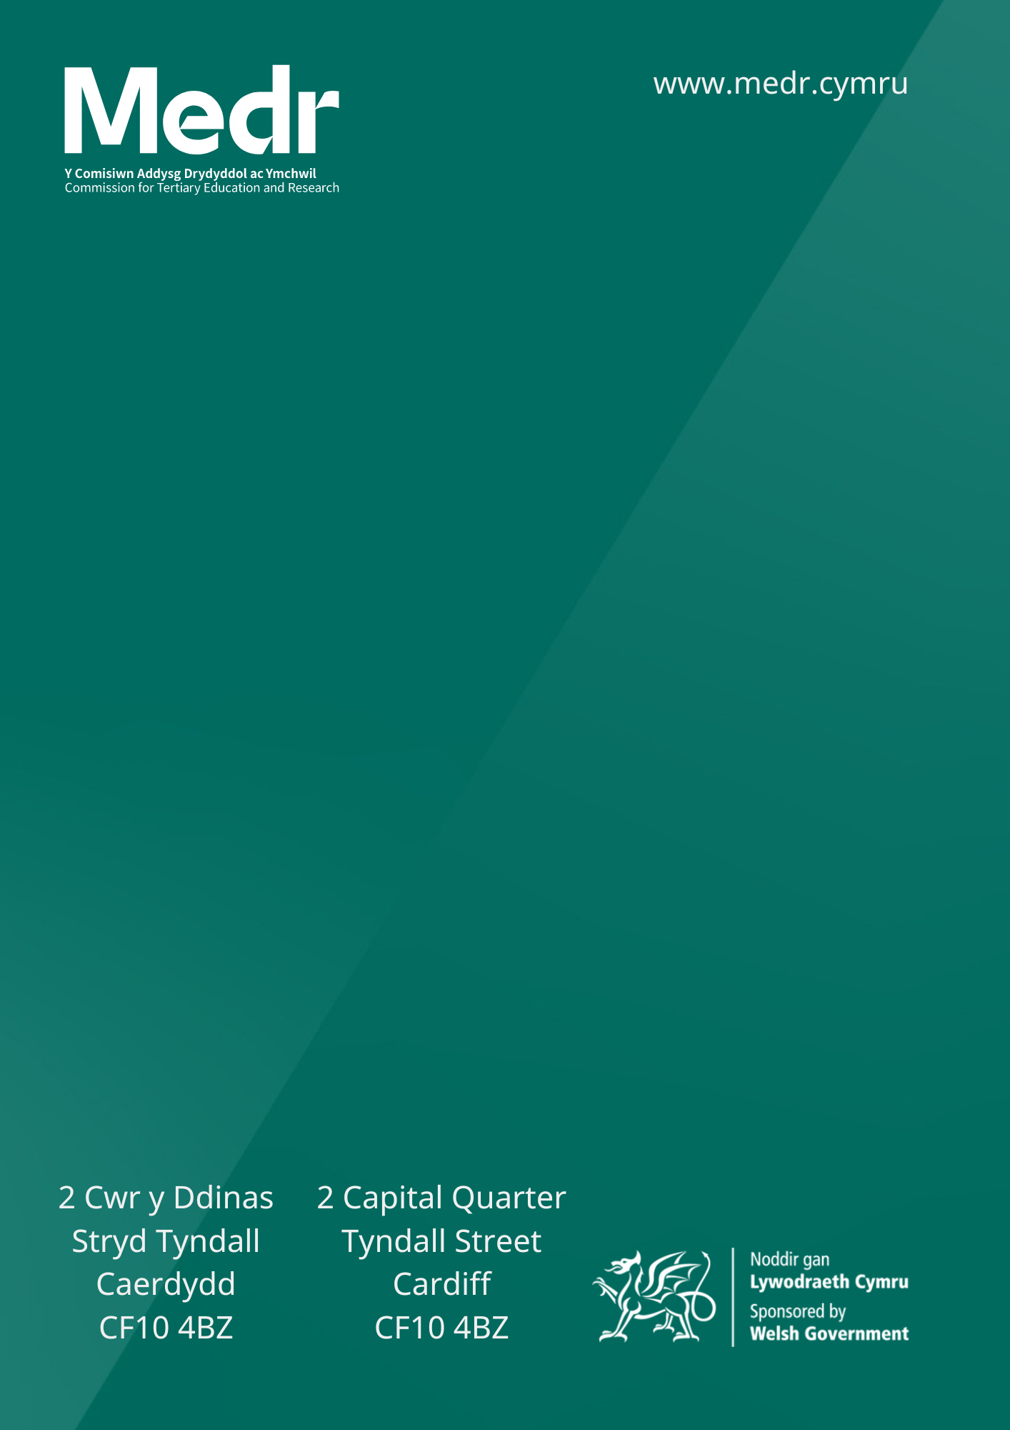

The Additional Learning Needs Code
This is not a medical diagnostic assessment, rather one used by the FEI to determine the needs of learners and the appropriate ALP.

